**DAILY ONLINE ACTIVITIES SUMMARY**

|  |  |  |  |  |  |
| --- | --- | --- | --- | --- | --- |
| **Date:** | | **02/06/2020** | **Name:** | **JASLINE SHARON TAURO** | |
| **Sem & Sec** | | **4th sem, A Section** | **USN:** | **4AL18CS029** | |
| **Online Test Summary** | | | | | |
| **Subject** | **N/A** | | | | |
| **Max. Marks** | **N/A** | | **Score** | **N/A** | |
| **Certification Course Summary** | | | | | |
| **Course** | | **Python for Machine Learning** | | | |
| **Certificate Provider** | | **Great Learning** | **Duration:** | | **4 HRS** |
| **Coding Challenges** | | | | | |
| **Problem Statement:**   1. Given an array of positive integers. Write a C Program to find inversion count of array. 2. Write a Java program to find Perfect Sum Problem 3. Write a program in java, an array of integer data to be initialized. During the initialization, if a user enters a value other than integer value, then it will throw InputMismatchException exception. On the occurrence of such an exception, your program should print “You entered bad data.” If there is no such exception it will print the total sum of the array | | | | | |
| **Status: DONE** | | | | | |
| **Uploaded the report in GitHub** | | | **YES** | | |
| **If yes Repository name** | | | [**https://github.com/jaslinesharontauro/C_Prgms**](https://github.com/jaslinesharontauro/C_Prgms)  <https://github.com/jaslinesharontauro/JAVA_Prgms> | | |
| **Uploaded the report in slack** | | | **YES** | | |

**Online Test Details: (Attach the snapshot and briefly write the report for the same)**

**Certification Course Details: (Attach the snapshot and briefly write the report for the same)**

**Coding Challenges Details: (Attach the snapshot and briefly write the report for the same)**

**1.CERTIFICATION COURSE DETAILS**

**Today I have done the Course named Python for Machine Learning by Great Learning. Today I have learnt basics of python programming language, Installation of Anaconda, and the basics of Jupyter.**

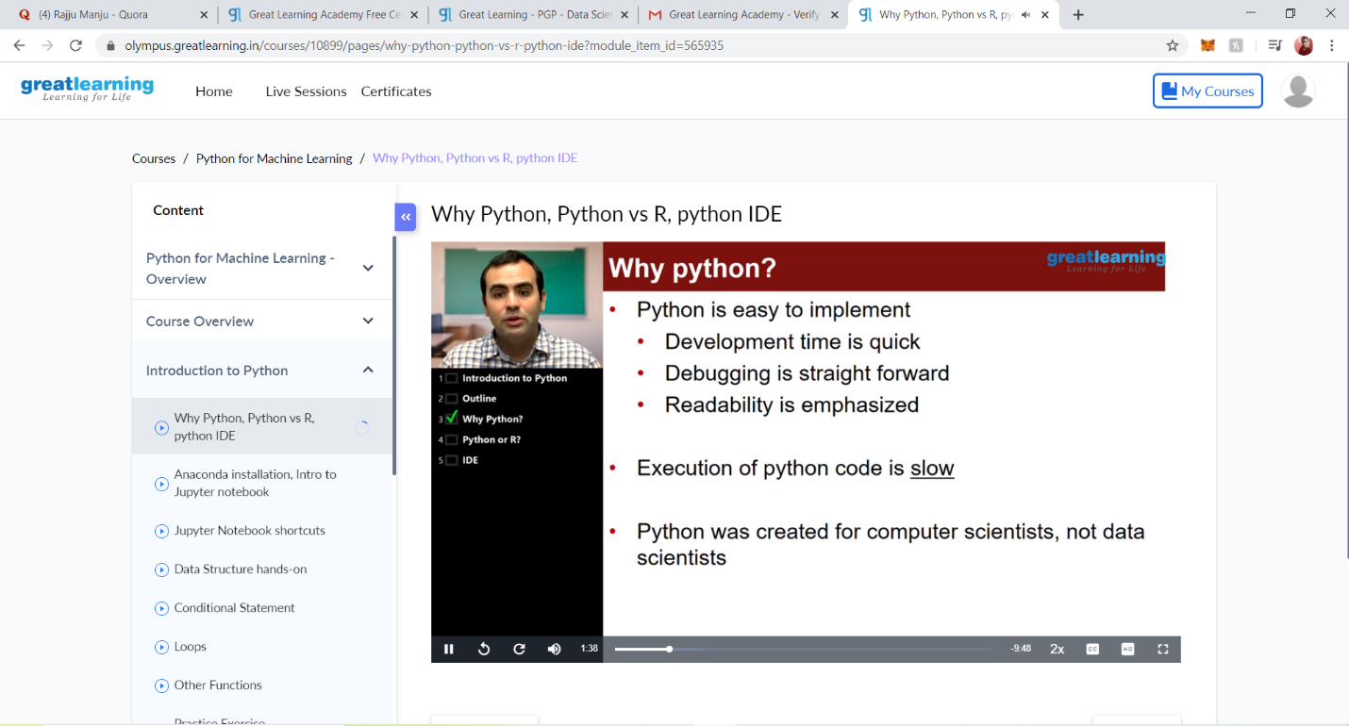





**3.CODING CHALLENGES DETAILS:**

**Problem statement 1:**

1. Given an array of positive integers. Write a C Program to find inversion count of array.

**Inversion Count:** For an array, inversion count indicates how far (or close) the array is from being sorted. If array is already sorted then inversion count is 0. If array is sorted in reverse order that inversion count is the maximum.  
Formally, two elements a[i] and a[j] form an inversion if a[i] > a[j] and i < j.  
**Input:**  
The first line of input contains an integer T denoting the number of test cases. The first line of each test case is N, the size of array. The second line of each test case contains N elements.  
**Output:**  
Print the inversion count of array.  
**Constraints:**  
1 ≤ T ≤ 100  
1 ≤ N ≤ 107  
1 ≤ C ≤ 1018  
**Example:  
Input:**  
1  
5  
2 4 1 3 5  
Output:  
3  
**Explanation:  
Testcase 1:** The sequence 2, 4, 1, 3, 5 has three inversions (2, 1), (4, 1), (4, 3).

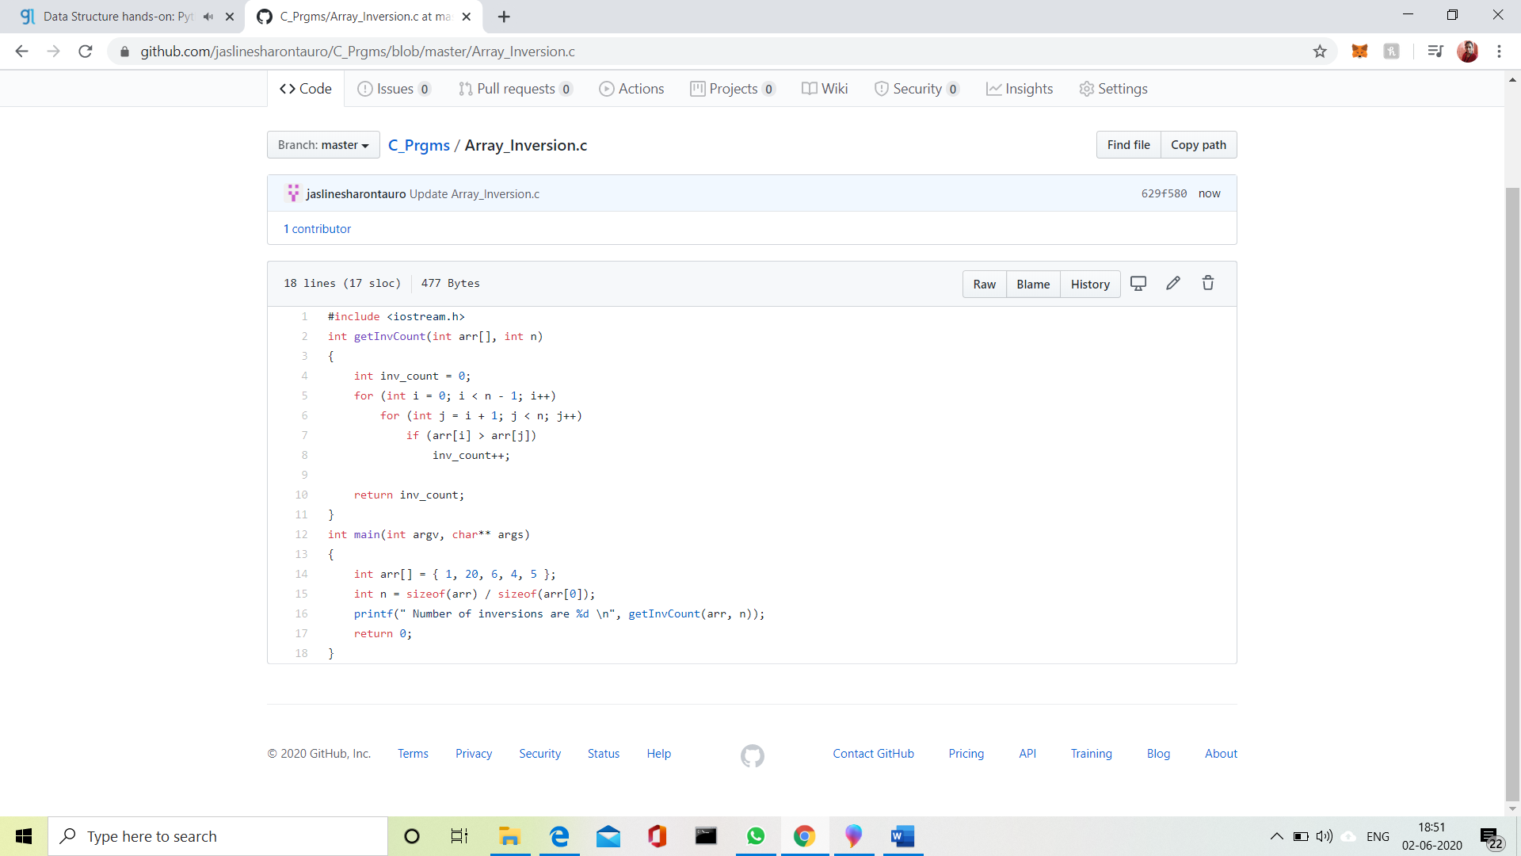

## 

Problem Statement 2:

Write a Java program to find Perfect Sum Problem

Given an array arr[] of integers and an integer K, the task is to print all subsets of the given array with the sum equal to the given target K.

**Examples:**

**Input:** arr[] = {5, 10, 12, 13, 15, 18}, K = 30  
**Output:** {12, 18}, {5, 12, 13}, {5, 10, 15}  
**Explanation:**  
Subsets with sum 30 are:  
12 + 18 = 30  
5 + 12 + 13 = 30  
5 + 10 + 15 = 30

Input: arr[] = {1, 2, 3, 4}, K = 5  
Output: {2, 3}, {1, 4}

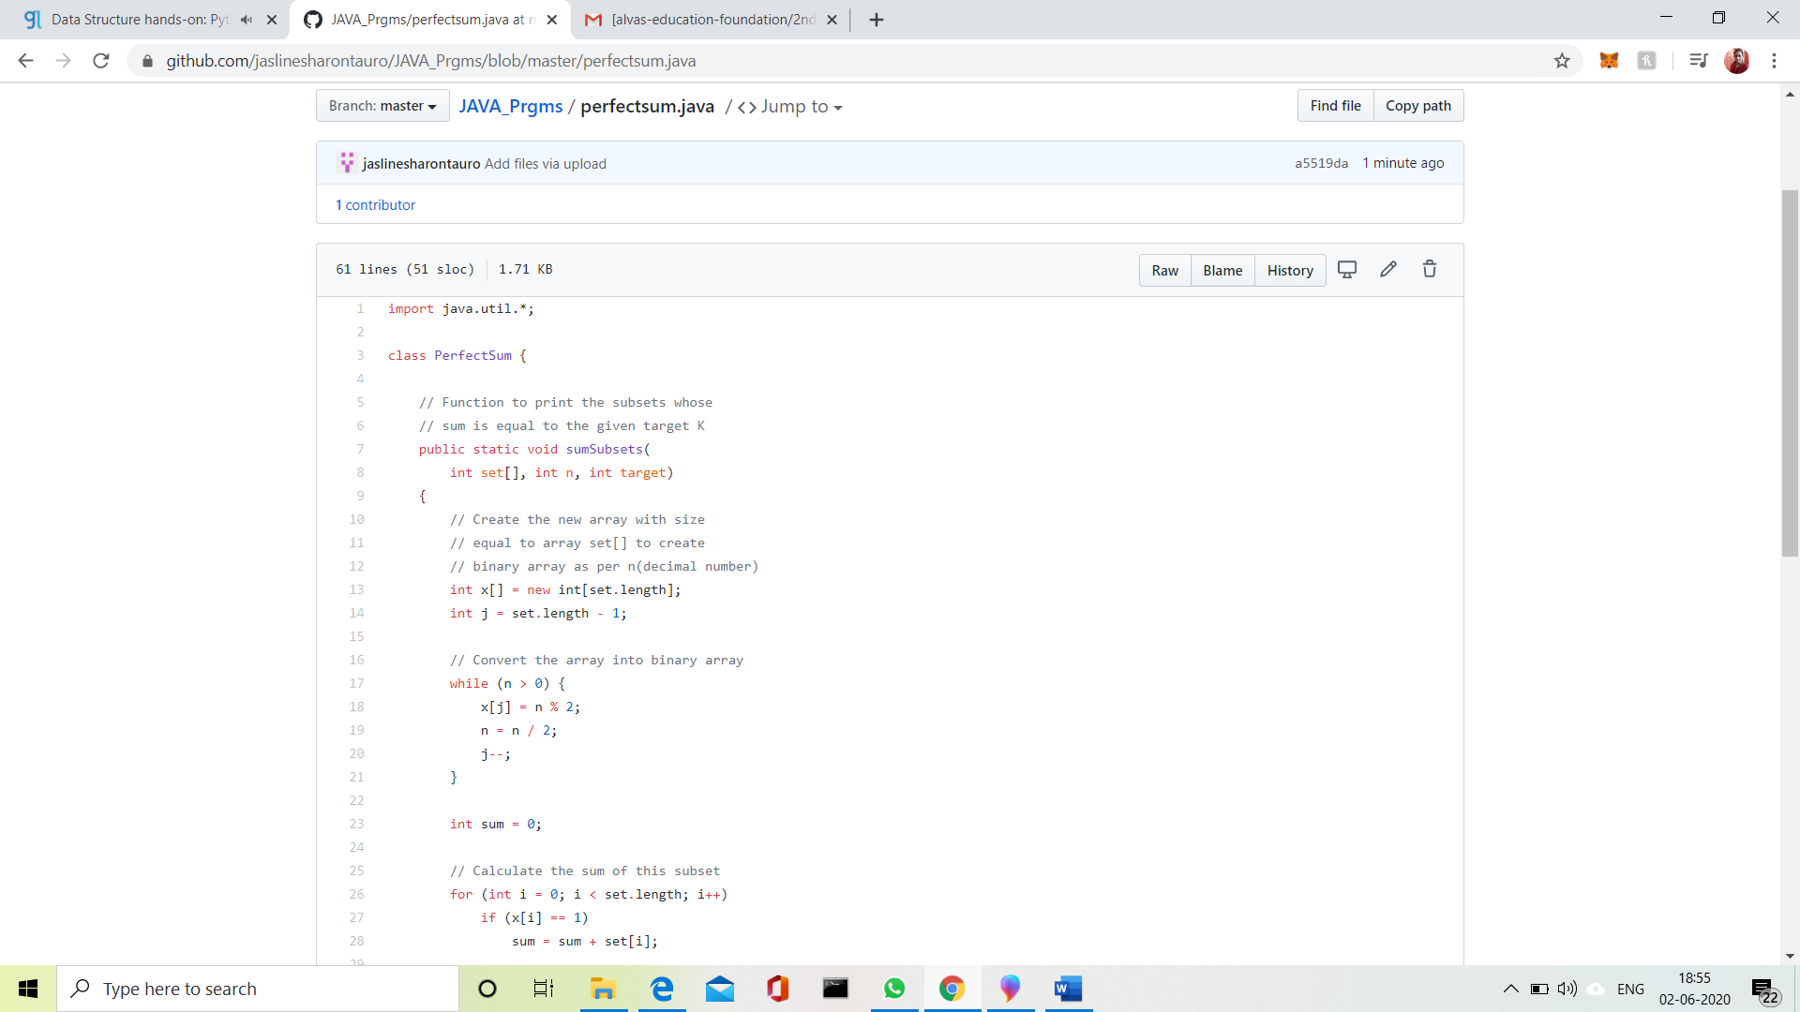

Problem Statement 3:

Write a program in java, an array of integer data to be initialized. During the initialization, if a user enters a value other than integer value, then it will throw InputMismatchException exception. On the occurrence of such an exception, your program should print “You entered bad data.” If there is no such exception it will print the total sum of the array.

